Name:

2.2 Cell Metabolism | Objectives
2.2.1 Metabolism | - Define the term: metabolism.
2.2.2 Sources of energy | - State that solar energy is source of energy on Earth.  - State that cellular energy sourced from chemical energy in ATP.
2.2.3 Enzymes | - Define the term: enzymes  - State the nature, folded shape & functions of enzymes.  - Explain the role of enzymes in plants and animals including role in metabolism  - Explain the effects of pH & temperature on enzyme activity.  - State the procedure and advantages of Bio-processing.  - State the use of Bio-processing.  - Explain the active site theory to examine enzyme function & specificity.  - Explain the term optimum activity with reference to temperature.  - Explain the nature of heat denaturation
2.2.7.H Enzymes Extended Study | - Explain the active site theory to examine enzyme function & specificity.  - Explain the term optimum activity with reference to temperature.  - Explain the nature of heat denaturation
Practical activities
ME - Investigate effect of pH on enzyme rate
ME - Investigate effect of temperature on enzyme rate
ME - Prepare one enzyme immobilisation and examine its application
ME - Investigate the effect of heat denaturation on catalase activity

Metabolism is the sum of all the chemical reactions in organisms.

Enzyme reactions can be catabolic (breakdown)
i.e. AB A + B e.g. respiration, digestion

or anabolic (synthetic – involves the production of large biomolecules)
i.e. A + B AB e.g. photosynthesis, protein synthesis.

Catabolic reactions release energy and anabolic reactions require energy normally.
Living organisms obtain their energy either directly from the sun or from food (solar energy or chemical energy). In organisms energy is released from the energy stored in bonds of biomolecules during respiration, some is stored and used by the cells in other biochemical reactions, the rest is released as heat.
Enzymes are biological catalysts that control metabolism.

Properties of enzymes

- Biological catalysts, which can speed up reactions without being used up. They lower the activation energy of the reaction (the amount of energy required to trigger molecules to begin reacting).
- Proteins, with a particular 3D shape, are produced in living cells.
- Specific for a particular substrate. One enzyme per reaction.
- Enzymes can work in both directions (reversible).
- The activity of the catalyst varies with temperature, pH, enzyme conc., substrate conc., product conc. and enzyme inhibitors.
Some enzymes require cofactors such as minerals, vitamins and sometimes other enzymes to work efficiently.

Enzyme inhibitors
Inhibitors are chemicals that attach to an enzyme and destroy its shape e.g.
- heavy metals - arsenic, mercury, lead, silver, gold salts.
- nerve gases e.g. sarin - attack enzymes involved in nerve impulse transmission.
- cyanide - blocks an enzyme involved in respiration.
- Antibiotics, drugs, some insecticides – act as inhibitors of enzymes that are not present in humans. They affect other organisms e.g. insects and bacteria.

Naming enzymes - all enzymes are named by adding the suffix -ase to the substrate they act on e.g. lipase acts on lipids.

Amylase (catabolic enzyme) breaks down starch into maltose.
DNA polymerase – an anabolic enzyme that forms and repairs damaged DNA.

Mechanism of enzyme action
- Substrate combines with the active site of enzyme.
- Induced fit theory – when the substrate joins the enzyme it will change the shape of the active site slightly to make a better fit for the substrate.
- A temporary enzyme-substrate complex is produced. The bonds in the substrate are altered so that the substrate changes into the product(s).
- Products leave active site. Active site returns to original shape and can now accept a new substrate.
The mechanism was often referred to as the lock and theory. Substrate = lock and enzyme = key.

Diagram E + S → ESC → P + E

Reaction rate is the amount of product formed per unit time or the amount of substrate used up per unit time.

Factors affecting the rate of enzyme action
1. Temperature

The activity of the catalyst varies with temperature. At low temp. the molecules move slowly and collide infrequently, so a low rate of reaction. If too low the enzymes are inactivated. Higher temp. means more frequent collisions so a higher rate. Above optimum temp. shape of active site is altered, so enzyme denatured i.e. their function is permanently destroyed by high temperatures, so rate falls. (humans = 37ºC, plants = 20-30ºC

2. pH

Most enzymes work within a narrow pH around neutral - can be denatured by a large change in pH i.e. shape of active site altered. Effects of pH are reversible.

Optimum pHs e.g. Pepsin pH 2, most enzymes = 7

3. Substrate concentration
The greater the number of substrate (reactant) molecules, the faster the reaction up to a certain conc. when all active sites have been occupied.

4. Enzyme concentration

In general, the more enzyme the faster the reaction - due to frequent collisions, provided that there is plenty of substrate.

Denaturation
When heated above 60ºC (or treated with certain chemicals or radiation) most enzymes lose their 3D shape and thus lose their ability to react with a substrate.
White of an egg is denatured when boiled. Note amylase can withstand temperatures above 40ºC.
Biotechnology is the use of organisms or their enzymes to produce commercial products.

Immobilisation of cells and enzymes
Bioprocessing is the use of enzymes-controlled reactions to produce a product.
Immobilised enzymes are enzymes that are attached, or fixed, to each other, or to an inert material.
Methods of immobilizing enzymes. – attached to each other, to insoluble supports or enclosed within a membrane or gel.
Adsorption = enzymes or physically attached to inactive supports e.g. glass beads, ceramics, cellulose particles or artificial polymers.
Sodium alginate is used to trap the enzymes in a gel. This material is prepared from algae and is permeable to the entry of the substrate and to the exit of the products.

Advantages of enzyme immobilization
- The efficiency of the enzyme (how quick it catalyses a reaction) is not affected by the immobilization process
- Enzyme is insoluble and easier to recover and reuse, thus cutting costs and increasing efficiency. The nutrient can be continually added and the product (without being contaminated with m/o or enzymes) easily removed if the beads are in a column.
- Product is not contaminated with the enzyme – this reduces the possibility of allergic reactions to the enzyme.
- Enzyme is more stable. This reduces the amount of enzyme needed in the reaction.
- The arrangement is perfect for multi-step processes – different enzymes can be added to different parts of the enzyme tower.

Applications of immobilized enzymes
- Produce sweet-tasting sugars from whey. Lactase is used to convert lactose (found in whey - a byproduct of cheese-making) into the sweeter sugars, glucose and galactose. These sugars are used to replace condensed milk in the manufacture of soft toffee and caramel.
- Produce fructose (sweetener) from glucose. Glucose isomerase is used to convert glucose to the sweeter-tasting fructose, used in soft drinks.
- Convert penicillin to different forms– penicillin acylase is used to alter the structure of penicillin, thus allowing the development of new antibiotics e.g. ampicillin that may kill a wider range of bacteria.

Yeast contains sucrase which breaks down sucrose. Product can be tested for glucose.

Energy carriers

ATP

Adenosine diphosphate
Adenine –ribose –P-P-P
Energy is needed in small amounts for metabolic reactions. ATP releases energy when it breaks down to ADP and P. ATP is made in respiration and in photosynthesis where it is needed to make glucose.
ATP → ADP + P
ADP + P → ATP (phosphorylation)
NADH is an electron carrier used in respiration
Nicotinamide adenine dinucleotide phosphate
NADPH is used in photosynthesis to form glucose.
NADPH → NADP⁺ + 2 electrons + H⁺
(high-energy) (low-energy)

Section A – Short questions

SEC Sample Paper HL
2. Select the correct term from the following list to match each of the terms in column A and write it in
column B.

protein, enzyme, uracil, sap, ethanol, mutation, thymine, chlorophyll.

A | B
Active Site

2004 HL
1. (b) Give an example of a catabolic reaction ………………

2006 HL
3. The graph shows how the rate of reaction of a carbohydrate-digesting enzyme in the human alimentary canal varies with pH.
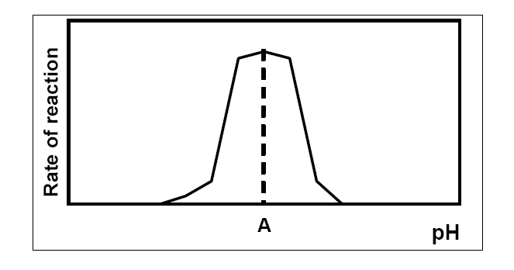
(e) A is said to be the enzyme’s ………………………….pH
(f) Suggest a temperature at which human enzymes work best ……..……………………..
(g) What term best describes the shape of an enzyme? …………………………….………

2013 HL
1. In the case of any five of the following pairs of terms, clearly distinguish between the first term and second
term by writing a brief sentence about each.
(d) Enzymes. _______________________________________________________________________

Section B
SEC Sample Paper HL
7. (a) To which group of molecules do enzymes belong? ………………………………………………
What is a denatured enzyme? ……………………………………………………………………..
(b) Answer the following by reference to an experiment that you carried out to investigate the effect of pH on the rate of enzyme action.
Name the enzyme and substrate that you used. ……………………………………………………….
Draw a labelled diagram of the apparatus that you used.
Explain how you varied the pH. .…….………………………………………………………
State one factor that you kept constant in this experiment. …...……………………………..
How did you ensure that this factor was kept constant? ……….……………………………
Label the axes and draw a graph of the results that you obtained.

2005 HL
7. (a) Immobilised enzymes are sometimes used in bioreactors.
(i) What is a bioreactor? ………………………………………………………………………………
(ii) State one advantage of using an immobilised enzyme in a bioreactor.
(b) Answer the following questions in relation to an experiment that you carried out to immobilize an enzyme and use that immobilised enzyme.
(i) Name the enzyme that you used ………………………………………………………………..…
- Draw a labelled diagram of the apparatus that you used to immobilise the enzyme.
- Describe how you used this apparatus to immobilise the enzyme. In your answer name the solutions that you used and explain their purpose.
(iv) Describe briefly how you used the immobilised enzyme.
2007 HL
7. (a) (i) What is meant by an enzyme? ……………………….………………………………..
(b) Answer the following questions in relation to an investigation that you carried out to determine the effect of temperature on enzyme action.
(i) Name the enzyme that you used. ………………………………………………………..
(ii) Name the substrate of the enzyme. ………………………………………………..……
- State one factor that you kept constant during the investigation ………….…………..
- How did you keep this factor constant?
- How did you vary the temperature? ……………………………………………………
- How did you measure the rate of activity of the enzyme? ………………………..…

- What was the result of your investigation?

2008 HL
9. (a) (i) What is meant by an enzyme’s optimum pH? ………………………………………………..
(ii) What is a denatured enzyme?....……………………………………………………………….

(b) In the course of your studies you investigated the effect of denaturation by heat application on the
activity of an enzyme.
(i) Name the enzyme that you used………………………………………………………………
(ii) What substrate did you use? ………………………………………………………………….
(iii) Describe how you carried out the investigation. In your answer you must refer to the way that you measured the enzyme’s activity..…………………………………………………...............
(iv) State the results that you obtained.

2009 HL
9. (a) (i) To which group of biomolecules do enzymes belong? ______________________________
(ii) Name a factor that influences the activity of an enzyme.
__________________________________________________________________________
(b) In the course of your practical investigations you prepared an enzyme immobilisation.
Answer the following questions in relation to that investigation.
- Describe how you carried out the immobilisation.
(ii) In the space provided draw a labelled diagram of the apparatus that you used to investigate
the activity of the immobilised enzyme.
(iii) Briefly outline how you used the apparatus referred to in (b) (ii) above.
2011 HL
8. (a) State a use for each of the following in the biology laboratory:
(i) Buffer solution. ____________________________________________________________

2012 HL
9. (a) Answer the following in relation to enzymes.
(i) What is their chemical nature? _________________________________________________
(ii) Comment upon their molecular shape. ___________________________________________
(b) Answer the following in relation to an investigation that you carried out into the effect of
temperature on the rate of enzyme action.
(i) Name the enzyme that you used.
(ii) Name the substrate of this enzyme.
(iii) Why was it necessary to keep the pH constant in the course of the investigation?
(iv) How did you keep the pH constant?
(v) How did you vary the temperature in the course of the investigation?
(vi) How did you know that the enzyme was working?
(vii) Use the axes below to summarise the results of your investigation.
Do this by
1. labelling the axes,
2. drawing a graph to show how the rate of enzyme action varied with temperature.
2013 HL
8. (a) (i) What term is used for the substance(s) that result(s) from the action of an enzyme on its
substrate? _______________________________________________________________________
(ii) In relation to an enzyme, explain the term optimum activity.
(b) Answer the following in relation to an activity that you carried out to investigate the effect of
heat denaturation on the activity of an enzyme.
(i) Name the enzyme and the substrate that you used.
Enzyme. _________________________________________________________________________
Substrate. ________________________________________________________________________
(ii) Describe how you carried out the investigation.
In your description outline how you measured the activity of the enzyme.
- Using suitably labelled axes, draw a graph of the results that you obtained.
2015 HL 7©
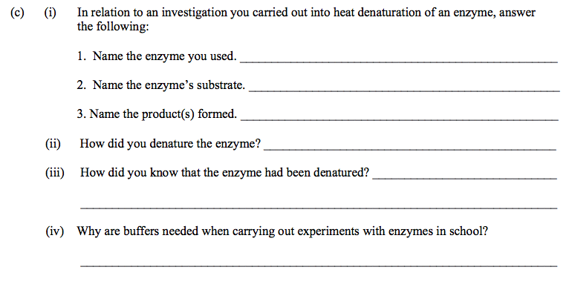
2016 HL 7(b)(iv)
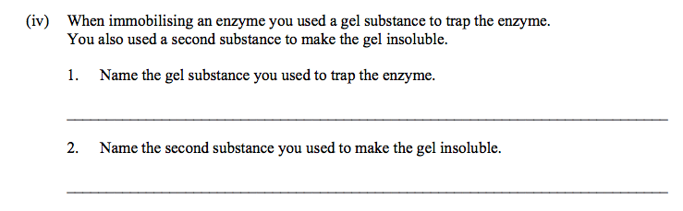

2017 HL 8
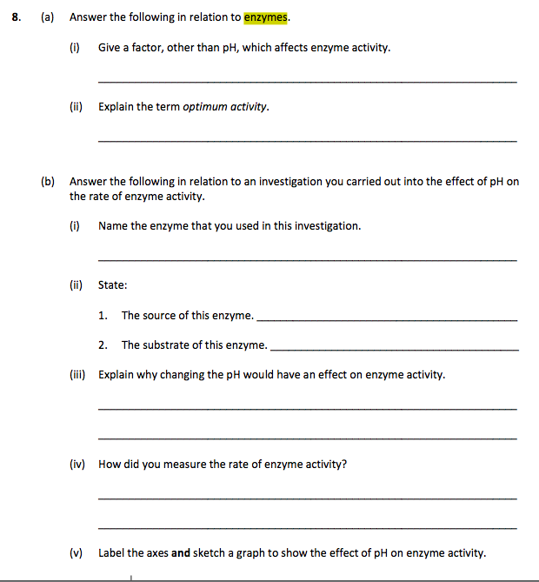

Section C
2007 HL
11 (c) Enzymes can be immobilised and then used in bioprocessing.
(i) What is meant by immobilisation?
(ii) Name a substance that is used to immobilise enzymes.
(iii) Give two advantages of using immobilised enzymes.
(iv) Give one application of a named immobilised enzyme. In your answer, refer to substrate, enzyme and product. (24)
2010 HL
14. (30)
(b) (i) What is an enzyme?
(ii) What is meant by the specificity of an enzyme?
(iii) Explain how the Active Site Theory may be used to explain the specificity of enzymes.
(iv) Bioprocessing often involves the use of immobilised enzymes in a bioreactor.
- What does the term immobilisation refer to when used about enzymes?
- Explain the term bioreactor.
(v) Give one example of the use of immobilised enzymes in bioreactors.
In your answer name the enzyme, the substrate and the product.

2011 HL
14. (b) (i) What is meant by the term metabolism?
(ii) “Enzymes are essential for metabolism”.
Explain why this statement is true.
(iii) In each of the following cases state whether the process is anabolic or catabolic.
1. Protein synthesis.
2. Conversion of ADP to ATP.
3. Reactions in which product molecules are larger than substrate molecules.
(iv) State one way by which an enzyme may be denatured.
(v) Give two features of a denatured enzyme.
(vi) Apart from carbon, hydrogen and oxygen, there is one other element always present in the
building blocks of enzymes. Name that element.
2014 HL Q13

2018 HL Q12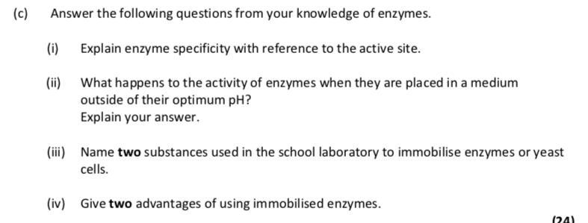

Enzyme answers
Section A

2004 HL Sample Q2
6(3)+2
Active Site | Enzyme

2004 HL Q1
1. |  |  | 2(7)+3(2)
 | (b) | Respiration or digestion or deamination or any correctly described reaction  e.g. protein → amino acids or equation

2006 HL Q3
3. |  |  | 6(3)+2
 | (e) | optimum
 | (f) | 35 ⁰C - 40 ⁰C
 | (g) | folded or described

2013 HL Q1
1. | 5(4, 2, 0) i.e. best five answers from (a) – (f)
 | (d) | Enzyme | – a catalyst (or explained)

3. |  |  | 2(5)+5(2)
 | (d) | T

Section B

2004 HL Q7
7. | (a) |  | Yes | 3
 |  |  | (Rate of) enzyme reaction (affected by temperature) | 3
 | (b) |  | Diagram  [must include evidence of anaerobic conditions and two correct labels for 3 marks] | 3, 0
 |  |  | Sugar or named sugar or starch | 3
 |  |  | Carbon dioxide or any product of glycolysis | 3
 |  |  | Yeast absent (or dead) in same set up | 3
 |  |  | Comparison or purpose described | 3
 |  |  | No more gas given off (no more bubbles) | 3
 |  |  | *NB - To test for alcohol – All candidates who attempt Q | 3
 |  |  | Water (allow other correct product from Kreb’s cycle) | 3

2005 HL Q7
7. | (a) | (i) | A vessel / container / named industrial example e.g. vat | 3
 |  | (ii) | (Enzyme) - can be recovered | 3
 | (b) | (i) | Name of enzyme / yeast | 3
 |  | (ii) | Diagram of apparatus (2 pieces) + one label | 3
 |  | (iii) | Use of apparatus e.g. beaker/ stirrer/ syringe  Names of solutions e.g sodium alginate/ calcium chloride  Purpose e.g. to trap enzyme/ form beads  Sodium alginate / calcium chloride are compulsory points  any four – at least one from each | 4(3)
 |  | (iv) | Named substrate or named product / comment on procedure | 2(3)

2007 HL Q7
7.
 | (a) | (i) | biological or organic or metabolic or protein catalyst or explained | 3
 |  | (ii) | keratin or myosin or other correct | 3
 | (b) | (i) | name of enzyme | 3
 |  | (ii) | name of matching substrate | 3
 |  | (iii) | pH or substrate concentration or enzyme concentration [allow amount] | 3
 |  | (iv) | buffer or same volume or same amount | 3
 |  | (v) | water baths or described or water bath at different temperatures or  described | 3
 |  | (vi) | time / change e.g. colour, foam, etc  or data logger / sensor named | 2(3)
 |  | (vii) | activity varies with temperature or reference to activity at a particular temperature | 3

2008 HL Q9
9. | (a) | (i) | (pH at which enzyme) works best | 3
 |  | (ii) | Loss of (enzyme) function (or activity) | 3
 | (b) | (i) | name of enzyme | 3
 |  | (ii) | name of substrate (must match if enzyme named) | 3
 |  | (iii) | how activity measured (must match enzyme or match substrate)  other procedures:  how heated / how long / addition (of or to substrate) / control described / suitable condition or example (for both experiment and control) | 3  3(3)
 |  | (iv) | Result of experiment and result of control | 6,0

2009 HL Q9
9. | (a) | (i) | Proteins | 3
 |  | (ii) | Temperature or pH | 3
 | (b) | (i) | Named enzyme [accept yeast] / mix (or stir) / with alginate / add to  CaCl₂ soln. / how added / (allow to) harden | 3(3)
 |  | (ii) | Diagram: | 2,0
 |  |  | Labels: named substrate / enzyme [accept yeast] or beads / named  product / any one apparatus label | 2(2)
 |  | (iii) | Add substrate (to immobilised enzyme) / test for named product /  how tested / test at set intervals or control described | 3(3)

2011 HL Q8
8. | (a) | (i) | To keep pH constant | 3

2012 HL Q9
9. | (a) | (i) | Protein |  | 3
 |  | (ii) | Folded |  | 3
 | (b) | (i) | Name of enzyme |  | 3
 |  | (ii) | Matching substrate |  | 3
 |  | (iii) | To eliminate it as a possible influence on rate or only one variable |  | 3
 |  | (iv) | Buffer |  | 3
 |  | (v) | Water baths or water bath at different temperatures |  | 3
 |  | (vi) | Description of visible result matching enzyme (or substrate) |  | 3
 |  | (vii) | 1. | y-axis = Rate and x-axis = Temperature | 3
 |  |  | 2. |  | 3

2013 HL Q8
8. | (a) | (i) | Product(s) | 3
 |  | (ii) | Working at maximum rate | 3
 | (b) | (i) | Named enzyme | 3
 |  |  | Matching substrate | 3
 |  | (ii) | Temperature ≥ 60ºC for ≥ 5 min or boil / water bath or described / untreated enzyme / as control / no activity in denatured enzyme / (matching method of) observe activity / control result / named factor (kept constant) / how kept constant | 5(3)
 |  | (iii) | Any attempt | 3

2015 HL 7©
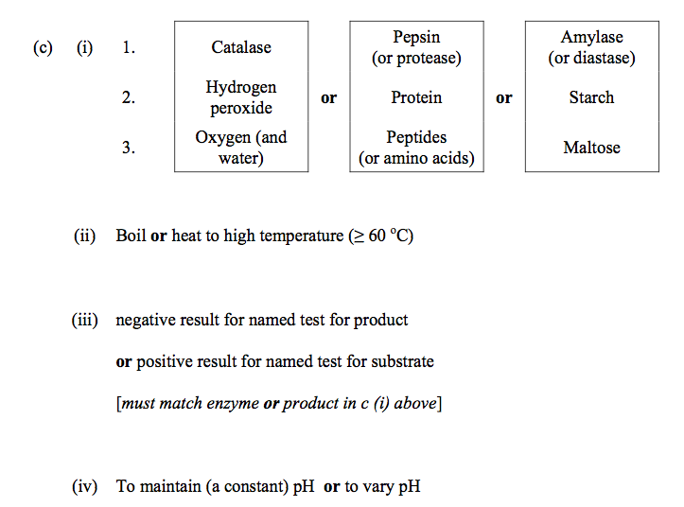

2016 HL 7(b)(v)
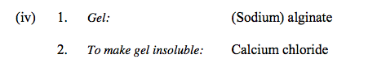

2017 HL 8

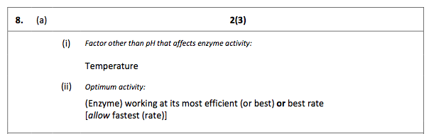

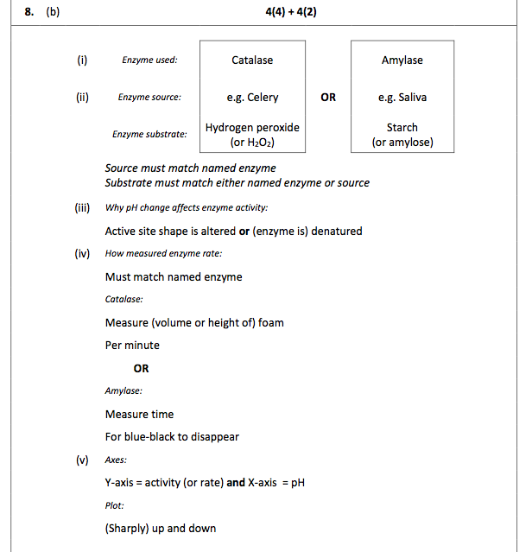

Section C

2007 HL Q11
 | (c) | (i) | attached or fixed or trapped / how or explained | 2(3)
 |  | (ii) | (calcium or sodium) alginate or other correct | 3
 |  | (iii) | enzyme can be reused / can be recovered / pure product / comment on cost or efficiency or stability or longer lasting | 2(3)
 |  | (iv) | enzyme name [allow yeast]  matching substrate name  matching product name or appplication | 3  3  3

2010 HL Q14(b)
14. | (b) | (i) | Biological (or protein) catalyst (or explained) |  | 3
 |  | (ii) | (Enzyme) acts on only a particular substrate |  | 3
 |  | (iii) | Substrate / matching enzyme’s active site / active site changes shape / (formation of) enzyme-substrate complex / product(s) formed  Any three |  | 3(3)
 |  | (iv) | 1. Immobilisation:  2. Bioreactor: | attached to an inert substance (or example of inert substance) or fixed to each other  vessel in which products are made by cells (or organisms) | 3  3
 |  | (v) | Enzyme  Substrate (must match enzyme)  Product (must match enzyme or substrate) |  | 3  3  3

2011 HL Q14(b)
14. | (b) | (i) | (All) the chemical reactions in living cells | 3
 |  | (ii) | (Enzymes) are catalysts  (Enzymes) control rate of (metabolic) reactions | 3  3
 |  | (iii) | - *Anabolic  - *Anabolic  - *Anabolic | 3(3)
 |  | (iv) | High temperature or high (or low) pH or agitation (or described) or high salinity or alcohol | 3
 |  | (v) | Changed structure  Loss of function | 3  3
 |  | (vi) | Nitrogen | 3

2014 Q13
2018 HL Q12
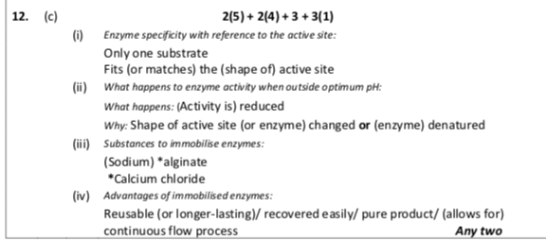

SEC Sample Paper OL
7. (a) What is an enzyme? …………………………………………………..……………………………….
What name is given to the substance that an enzyme acts on? ……………..…………………………

(b) Answer the following questions about an experiment that you carried out to investigate the effect of
temperature on the rate of action of an enzyme.
Name an enzyme that you used ………………………………………………………………………
Name the substance that this enzyme acted on ……………………………………………………….
Draw a labelled diagram of the apparatus that you used.

How did you vary the temperature?
How did you measure the rate of the enzyme’s action?
2005 OL
8. (a) (i) What is an enzyme? ……………………………………………………………………………
(ii) Comment on the shape of enzyme molecules. ………….……………………………………..
(b) Answer the following questions in relation to an experiment that you carried out to investigate the effect of temperature on enzyme activity.
(i) What enzyme did you use? ……………………………………………………………………
(ii) What substrate did you use? …………………………………………………………………..
(iii) Draw a labelled diagram of the apparatus that you used

(iv) How did you know that the enzyme had completed its activity?
(v) How did you vary the temperature in your experiment?
(vi) Draw an outline graph of the results that you obtained.

2007 OL
7. (a) (i) Is an enzyme a lipid, a protein or a carbohydrate? …………………………………………...
(ii) Where in a cell are enzymes produced? ………………………………………………

(b) As part of your practical activities you investigated the effect of temperature on the rate of
activity of an enzyme.
(i) Name the enzyme that you used ……………………………………………………………
(ii) Name the substrate with which the enzyme reacts …………………………………………
(iii) How did you vary the temperature? ………………………..…………………....................
(iv) How did you keep a constant pH during the investigation?
(v) How did you measure the rate of activity of the enzyme?
(vi) What was the result of your investigation?

2010 OL
8. (a) (i) What is an enzyme? __________________________________________________________
(ii) Explain what is meant by the term pH. ___________________________________________
(b) Answer the following questions in relation to your investigation into the effect of pH on the rate of
enzyme activity.
(i) Name the enzyme you used in this investigation. ____________________________________
(ii) Name
1. The substrate of this enzyme. _________________________________________________
2. The product of this enzyme. __________________________________________________
(iii) Draw a labelled diagram of the apparatus you used in your investigation
(iv) How did you vary the pH? _____________________________________________________
(v) Name one factor you kept constant. _____________________________________________
(vi) How did you keep the named factor constant? _____________________________________
(vii) Draw a graph, on the axes given below, to show the results of this investigation.

2011 OL
8. (b) For what purpose did you use each of the following in the course of your practical
activities?

(iv) Buffer solution.
Purpose. _________________________________________________________________
(vi) Sodium alginate.
Purpose. _________________________________________________________________
2012 OL
8. (a) (i) What is an enzyme? _____________________________________________________________
(ii) On what structures in the cytoplasm are enzymes made? ________________________________

(b) Answer the following questions in relation to an investigation that you carried out into the effect of
temperature on the rate of activity of an enzyme.
(i) What enzyme did you use? _______________________________________________________
(ii) What substrate did you use? ______________________________________________________
(iii) How did you vary the temperature during the investigation?_____________________________
(iv) How did you measure the rate of enzyme activity? ____________________________________
(v) During this investigation pH was kept constant. How did you keep the pH constant?
(vi) What was the result of your investigation?
2004 OL
13. (a) What is metabolism? Describe briefly the part played by enzymes in metabolism. (9)

2009 OL
15. (c) (i) To what group of biomolecules do enzymes belong?
(ii) Name the small molecules which are the building blocks for these biomolecules.
(iii) The action of the enzyme amylase on its substrate starch is an example of a catabolic
reaction. Explain each of the underlined terms.
(iv) What is meant by immobilisation of an enzyme?
(v) Describe how you immobilised an enzyme in the course of your practical work.
(vi) Give one advantage of bioprocessing using an immobilised enzyme.
(vii) Suggest one reason why enzymes are not found in body soap or shampoo.

2011 OL
12. (c) Enzymes are used in many processes in both plants and animals.
(i) What is an enzyme?
(ii) Name any one enzyme, and its substrate, and its product.
(iii) The rate of activity of enzymes can be affected by various factors.
Name any two factors that can affect enzyme activity.
(iv) Enzymes are sometimes immobilised in industrial processes.
What is meant by the term immobilised in relation to enzymes?
(v) Give one advantage of using immobilised enzymes.

2004 OL Q3
3. |  |  | 2(5)+5(2)
 |  | T

2013 OL Q5
5. |  |  |  | 5(4)
 | (a) |  | Proteins | (1 pt)
 | (b) |  | Temperature | (1 pt)
 | (c) |  | Immobilised | (1 pt)
 | (d) |  | Substrate | (1 pt)
 | (e) |  | Reusable | (1 pt)

2004 OL Sample Q7
7. | (a) | (i) | A biological/ organic/ protein catalyst | 3
 |  | (ii) | Substrate | 3
 | (b) |  | Catalase or amylase (must match substrate) | 3
 |  |  | Hydrogen peroxide or starch (must match enzyme used) | 3
 |  |  | Diagram of set up  Labels: water bath(s)/ test tubes/ solutions/ | 6,3,0  3(1)
 |  |  | Water baths/ at different temperatures/ thermostat | 3
 |  |  | Volumes of foam/ per minute/ disappearance of blue colour/ per minute | 3

2005 OL Q8
8. | (a) | (i) | organic/ biological/ protein catalyst |  | 3
 |  | (ii) | fits (substrate)/ active site / folded /can change shape |  | 3
 | (b) | (i) | name of enzyme | Matching answers | 3
 |  | (ii) | name of substrate | Matching answers | 3
 |  | (iii) | Diagram (minimum = beaker, solution, temp. reference)  Label – (title may be considered a label) |  | 6, 3, 0  3
 |  | (iv) | no more product/colour change / no more bubbles / no more foam |  | 3
 |  | (v0 | water bath/different temperature treatments / Bunsen / thermostat |  | 3
 |  | (vi) | graph (horizontal line or multi-peaked graph not acceptable) |  | 3

2007 OL Q7
7.
 | (a) | (i) | Protein | 3
 |  | (ii) | Ribosome | 3
 | (b) | (i) | name of enzyme | 6
 |  | (ii) | name of substrate [must match enzyme] | 3
 |  | (iii) | water bath or ice or thermostat | 3
 |  | (iv) | Buffer | 3
 |  | (v) | time / change (colour, height of foam, etc.)  OR  sensor / data logger | 2(3)
 |  | (Vi) | activity increases or enzyme has an optimum or graph showing increase | 3

2010 OL Q8
8. | (a) | (i) | A (biological) catalyst or explained |  | 5+1
 |  | (ii) | (A measure of) how acidic or alkaline a solution is [allow ‘neutral  or not’]
 | (b) | (i) | Name of enzyme: amylase or pepsin or catalase | 2(6) + 4(2) +1
 |  | (ii) | 1. Matching substrate
 |  |  | 2. Matching product
 |  | (iii) | Diagram: [minimum of test tube with substance in it] |  | 2, 0
 |  |  | Label: [one label] |  | 1
 |  | (iv) | Add acid or add base or add (different) buffers
 |  | (v) | Temperature
 |  | (vi) | Water bath
 |  | (vii) | Graph – any line that is not parallel to x axis and that is not ‘V’  shaped

2011 OL Q8
 | (b) | (iv) | To keep pH constant
 |  | (v) | To stain (animal/plant) cells / nucleic acids
 |  | (vi) | To immobilise enzymes (or yeast cells) /to make beads

2012 OL Q8
8. |  |  |  | 5 + 1
 | (a) | (i) | A biological or organic or protein catalyst. | (1 pt)
 |  | (ii) | Ribosome | (1 pt)
 |  |  |  | 2(6) + 6(2)
 | (b) | (i) | EG. Catalase | (1 pt)
 |  | (ii) | EG. Hydrogen peroxide (Must match enzyme) | (1 pt)
 |  | (iii) | Waterbath | (1 pt)
 |  | (iv) | EG. Volume of froth / time (Depends on enzyme used) | (2 pts)
 |  | (v) | Buffer | (1 pt)
 |  | (vi) | Increasing activity with increasing temp / works best at certain temp / activity decreases above or below certain temp. (Can be shown by graph with one axis labelled) | (2 pts)

2004 OL Q13
13. | (a) |  | metabolism – (chemical) reactions taking place in a cell or in an organism  enzymes are catalysts/ reactions in cells controlled by enzymes or  enzymes affect (initiate, speed up) chemical reactions | 3  2(3)

2009 OL Q15(c)
 |  |  |  | 11 +3 +8(2)
 |  | (i) | Proteins
 |  | (ii) | Amino Acids
 |  | (iii) | Substrate – substance changed (by enzyme)  Catabolic – (Breakdown of) large molecules into smaller ones
 |  | (iv) | Binding enzyme / in inert substance or Trapping enzyme/ in beads (gel)
 |  | (v) | (Enzyme) mixed / with alginate / (mixture) dropped / into CaCl₂ (solution) Two points
 |  | (vi) | e.g. Easy to separate / reuse / cheap / (allows) continuous production / more stable
 |  | (vii) | e.g. may damage skin

2011 OL Q12
12 | (c) | (i) | A biological (or organic or protein) / catalyst | 3(5)+6(2)  (2 Pts)
 |  | (ii) | Enzyme: any enzyme  Substrate: must match enzyme  Product: must match substrate or enzyme |  | (3 Pts)
 |  | (iii) | Temperature / pH |  | (2 Pts)
 |  | (iv) | Attached to a (inert)substance/ trapped / in beads |  | (1 Pt)

2004 OL
3. Indicate whether each of the following statements is true (T) or false (F) by drawing a circle around T or F.

Example: The pulmonary artery carries blood to the lungs T F

Immobilised enzymes can act as catalysts T F

2013 OL
5. Choose each term from the following list and place it in Column B to match a description in
Column A. The first one has been completed as an example.
List: Amylase; Temperature; Substrate; Immobilised; Reusable; Protein.

Column A | Column B
An example of an enzyme. | Amylase
(a) The group of biomolecules to which enzymes belong.
(b) Enzyme activity is affected by this.
(c) Enzymes trapped in an inactive material.
(d) The substance with which an enzyme reacts.
(e) Advantage of using immobilised enzymes.

